



**DEPARTMENT OF COMPUTER SCIENCE AND ENGINEERING**

# COMPUTER NETWORKS – CY245AT

### REPORT

**Submitted by**

**KAPSHA SURAJ SINGH 1RV23CY402**

**VARSHITH Y 1RV22CY059**

**Under the Guidance of:**

**Dr. Sandhya S**

**Assistant Professor**

**Department of CSE**

**RV College of Engineering®**

**Bengaluru - 560059**

### Computer Science and Engineering – Cybersecurity 2023-2024

**DECLARATION**

We, **KAPSHA SURAJ SINGH and VARSHITH Y**, students of fourth semester **BE** in **Computer Science and Engineering – Cyber Security**, **Department of Computer Science and Engineering,** RV College of Engineering®, Bengaluru, declare that the Computer Networks Experiential Learning with title **“Temporal Analysis and Prediction using CVE and CWE codes”,** has been carried out by us. It has been submitted in partial fulfillment for the award of degree in **BE** in **Computer Science and Engineering-Cyber Security** of RV College of Engineering®, Bengaluru, affiliated to Visvesvaraya Technological University, Belagavi, during the academic year **2023-24**. The matter embodied in this report has not been submitted to any other university or institution for the award of any other degree or diploma.

**Date of Submission: Signature of the Student**

**Student Name: KAPSHA SURAJ SINGH and VARSHITH Y**

USN: 1RV23CY402, 1RV22CY059

Department of Computer Science and Engineering RV College of Engineering®,

Bengaluru-560059

**TABLE OF CONTENTS**

* 1. Acknowledgement
  2. Abstract
  3. Chapter 1: Introduction
     + Introduction to CVE
     + Organizational Report
  4. Chapter 2: Theory and Concepts of Temporal analysis and prediction using CVE and CWE codes
     + Introduction
     + Vulnerability Scoring (CWE and CVSS Scoring System)
     + Requirements of CVE Vulnerability Prediction
     + Summary
  5. Chapter 3: High-Level Design of Temporal Analysis
     + Design Considerations
     + Architectural Strategies
     + System Architecture for Risk Prioritization Solution
     + Data Flow Diagrams
     + Summary
  6. Chapter 4: Implementation of Temporal analysis
     + Algorithm/Methodology
     + Source code
     + Summary
  7. Chapter 5: Experimental Results and Analysis
     + Performance Analysis
     + Observations
     + Summary
  8. Chapter 6: Conclusion and Future Scope
* Limitations
* Future Scope
  1. References

**ACKNOWLEDGEMENT**

We are indebted to **Rashtreeya Sikshana Samithi Trust**, Bengaluru for providing us with all the facilities needed for the successful completion of    Experiential Learning in Computer Networks Course at **Rashtreeya Vidyalaya College of Engineering (RVCE)** during the tenure of our Course.

We would like to thank **Dr. K N Subramanya, Principal,** for giving us an opportunity to be a part of RVCE and for his timely help and encouragement during the tenure of EL for Computer Network Course.

We are greatly thankful to **Dr. Ramakanth Kumar P., Professor and Head, Dept. of CSE** for his motivation and constant support during our tenure of EL for Computer Network Course.

We are greatly thankful to **Dr.Minal Moharir, Professor and Coordinator, BE CSE-Cyber Security** for her constant support during our tenure of EL for Computer Network Course..

We take this opportunity to convey my sincere gratitude to my internal guide **Dr. Sandhya S, Assistant Professor**, Dept of CSE, her advice, support and valuable suggestions that helped us to accomplish the EL for Computer Network Course Project in time.

We extend our thanks to all who have directly or indirectly extended their constant support for successful completion of our EL for Computer Network Course.Project.

KAPSHA SURAJ SINGH and VARSHITH Y

1RV22CY402, 1RV22CY059

**ABSTRACT**

Zero-day attacks pose a major challenge in cybersecurity by targeting vulnerabilities that remain unidentified at the time of the attack. This paper addresses this issue by leveraging the Common Weakness Enumeration (CWE) system—a well-established framework for identifying and categorizing software weaknesses—to predict potential zero-day attacks through a temporal analysis of historical CWE data. The study aims to uncover patterns that could signal emerging vulnerabilities, facilitating the development of proactive security measures.

The research employs a systematic approach to predict zero-day attacks by analyzing temporal trends in CWE data. It integrates statistical methods with time series analysis and predictive modeling to identify patterns indicative of emerging vulnerabilities. By examining historical data, the study seeks to establish a framework for forecasting potential zero-day attacks. The methodology involves evaluating the accuracy, precision, F1 score, and recall of the predictive model to ensure its effectiveness in identifying relevant CWE codes and minimizing false positives.

The proposed predictive model achieved an accuracy of 0.66, a precision of 0.65, an F1 score of 0.64, and a recall of 0.66. These metrics highlight the model's balanced performance in effectively identifying pertinent CWE codes while keeping false positives to a minimum. The results demonstrate the model’s capability to offer valuable insights into potential zero-day attacks, contributing to more robust cybersecurity defenses through enhanced predictive capabilities. This work is novel and not previously documented in the literature, emphasizing the significance of temporal analysis in forecasting and mitigating cybersecurity threats.

**CHAPTER 1: INTRODUCTION**

* 1. **Introduction of Software Exploitability**

This paper addresses the challenge of predicting zero-day attacks by leveraging the Common Weakness Enumeration (CWE) system. The CWE is a well-established framework developed to catalog and categorize software weaknesses and vulnerabilities, providing a standardized way to identify and address potential security issues. By analyzing historical CWE data, this research aims to uncover patterns and trends that could indicate emerging vulnerabilities before they are exploited. Temporal analysis, a method of examining data over time to identify patterns and trends, is employed to predict potential zero-day attacks. This approach is crucial for developing proactive security measures that can anticipate and address vulnerabilities before they are exploited.

The significance of this study lies in its innovative use of temporal analysis to predict zero-day attacks, a concept not extensively explored in existing literature. By systematically analyzing historical CWE data, the research seeks to provide insights into potential future threats, allowing organizations to implement more effective security measures. The proactive nature of this approach offers a strategic advantage in the fight against zero-day attacks, emphasizing the need for early detection and mitigation strategies. This paper contributes to the field of cybersecurity by presenting a new method for predicting zero-day attacks, highlighting the importance of leveraging historical data to enhance the effectiveness of security defenses.

**1.2 Organization of Report**

This report is organized into several chapters, each addressing different aspects of the research:

**Chapter 1: Introduction**

This chapter introduces the topic, discusses the significance of predicting CVE vulnerabilities.

**Chapter 2: Literature Review**

This chapter gives an overview of the literature survey that was done during the research. There are a total of 9 papers the are officially referred to here with relevance to our work

**Chapter 3: High-Level Design of Temporal Analysis**

This covers the **design considerations** and **architectural strategies** for developing a risk prioritization system. It presents the **system architecture** and **data flow diagrams** for analyzing potential cybersecurity threats. The **summary** highlights the importance of these design choices in building an effective temporal analysis solution.

**Chapter 4: Implementation of Temporal analysis**

The implementation of temporal analysis in this study involved systematically examining the frequency and timing of CWE occurrences over a defined period. This approach allowed for the identification of trends, seasonal patterns, and anomalies, which were then used to enhance the predictive accuracy of the model in forecasting emerging vulnerabilities.

**Chapter 5: Experimental Results and Analysis**

The experimental results and analysis demonstrated the model's effectiveness in predicting zero-day vulnerabilities, with performance metrics such as accuracy, precision, recall, and F1 score confirming its balanced capability. Detailed analysis of these results highlighted the model's strengths in identifying relevant CWE codes while minimizing false positives.

**Chapter 6: Conclusion and Future Scope**

The study successfully developed and implemented a predictive model for zero-day vulnerabilities using temporal analysis of CWE data. The model's balanced performance metrics underscore its effectiveness in forecasting emerging threats, contributing to proactive cybersecurity measures. By integrating temporal trends into vulnerability prediction, this research offers a robust approach to enhancing cybersecurity defenses against unpredictable zero-day attacks.

**CHAPTER 2: Theory and Concepts of Temporal analysis and prediction using CVE and CWE codes**

**Introduction**

Temporal analysis and prediction are critical in cybersecurity, especially for forecasting vulnerabilities and planning proactive defense mechanisms. In this context, the Common Vulnerabilities and Exposures (CVE) and Common Weakness Enumeration (CWE) codes serve as foundational elements for understanding and predicting potential threats. CVE is a publicly available list of information security vulnerabilities and exposures, while CWE is a community-developed list of software weaknesses. The integration of temporal analysis with CVE and CWE codes allows organizations to identify patterns over time that may indicate emerging threats or vulnerabilities. The ability to predict these vulnerabilities is crucial for risk management, enabling organizations to prioritize and address the most severe threats. This chapter explores the underlying theory and concepts related to temporal analysis and prediction using CVE and CWE codes, focusing on vulnerability scoring, requirements for CVE vulnerability prediction, and other relevant aspects.

**Vulnerability Scoring (CWE and CVSS Scoring System)**

* The CWE and Common Vulnerability Scoring System (CVSS) are essential tools in vulnerability management and prediction. CWE categorizes software weaknesses, providing a common language for describing vulnerabilities, while CVSS offers a framework for assessing the severity of vulnerabilities. Together, they provide a comprehensive understanding of the potential impact and exploitability of various software weaknesses.
* CWE is essential for identifying specific areas in software that are susceptible to exploitation. By categorizing vulnerabilities, CWE allows cybersecurity professionals to understand the types of weaknesses that are most prevalent and where efforts should be focused to mitigate them. For example, CWE codes such as "CWE-79" for Cross-Site Scripting (XSS) or "CWE-89" for SQL Injection help security teams understand what weaknesses exist and guide them on how to secure these areas effectively.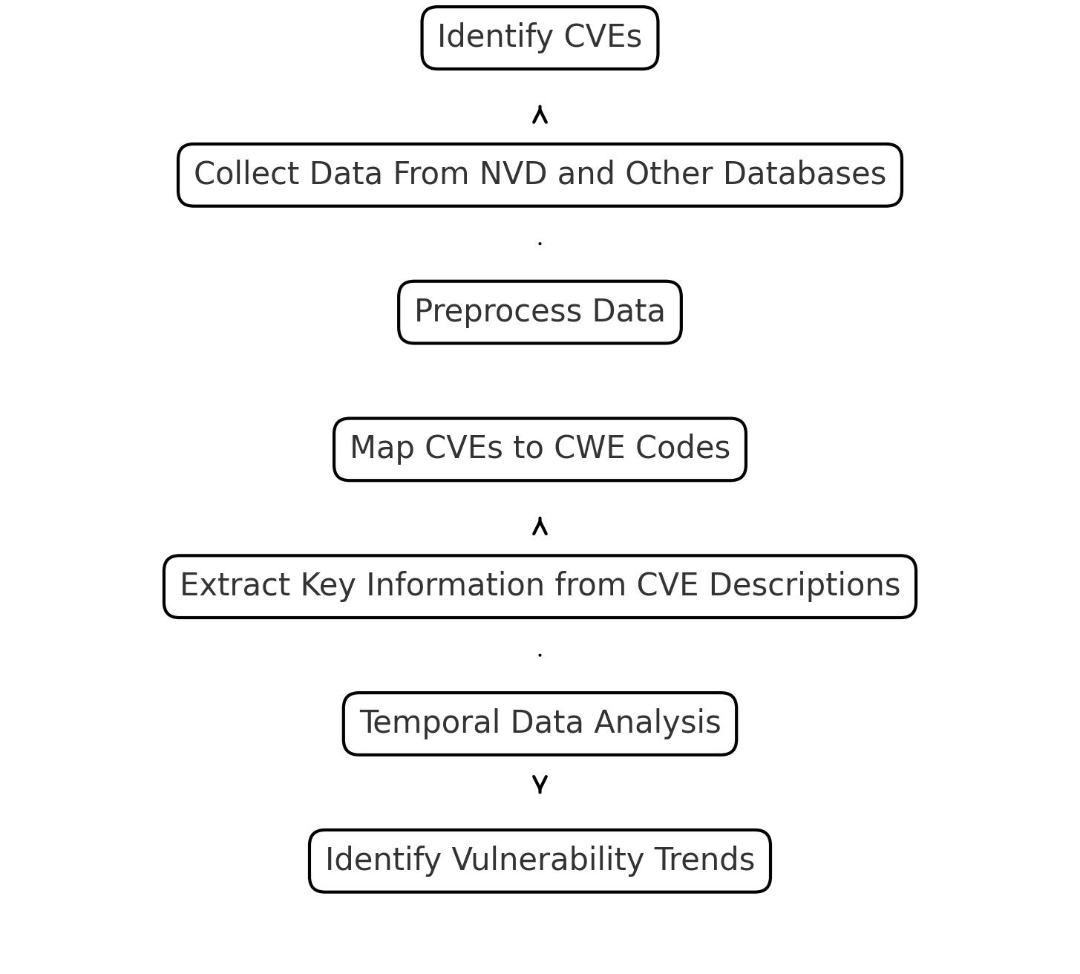
* On the other hand, the CVSS scoring system is used to assign severity scores to vulnerabilities, which are derived based on multiple factors, such as exploitability, impact, and the complexity of attacks required. The CVSS score ranges from 0 to 10, with a higher score indicating a more severe vulnerability. The CVSS model comprises three metric groups: Base, Temporal, and Environmental. The Base Score represents the intrinsic qualities of a vulnerability that are constant over time and across user environments. The Temporal Score adjusts the Base Score to reflect the characteristics of a vulnerability that change over time, such as the availability of exploits or patches. The Environmental Score further modifies the Base Score based on the potential impact of a vulnerability within a specific user's environment.
* Combining CWE and CVSS scoring systems allows for a detailed analysis of vulnerabilities. CWE provides context by describing the weakness, while CVSS quantifies its impact and likelihood. When applied to temporal analysis, these scoring systems can help track the evolution of specific vulnerabilities over time, identify trends, and predict which types of vulnerabilities are likely to be exploited in the future. This predictive capability is invaluable for developing robust cybersecurity strategies and ensuring effective risk management.

**Requirements of CVE Vulnerability Prediction**

1. To effectively predict vulnerabilities using CVE data, several key requirements must be met. First, a comprehensive dataset is essential. This dataset should include historical CVE entries, detailed descriptions of vulnerabilities, associated CWE codes, CVSS scores, and information on exploits and patches. The quality and completeness of the data significantly impact the accuracy and reliability of any predictive models.
2. Second, robust data preprocessing is necessary to clean and normalize the data. Inconsistent, incomplete, or redundant data can lead to inaccurate predictions, so it is vital to ensure that the dataset is well-prepared. Data preprocessing may involve removing duplicates, handling missing values, and standardizing data formats to ensure consistency across the dataset.
3. Third, advanced analytical techniques must be employed to derive meaningful insights from the data. Machine learning models, such as decision trees, support vector machines (SVM), or deep learning models, can be applied to identify patterns and predict future vulnerabilities. The choice of model depends on various factors, including the size and nature of the dataset, the specific prediction task, and the desired accuracy and interpretability of the model.
4. Fourth, temporal analysis techniques must be incorporated to account for the time dimension in vulnerability prediction. Understanding how vulnerabilities have evolved can provide insights into future trends. Time series analysis, for example, can be used to model the progression of vulnerabilities over time, identify seasonality and trends, and make future predictions. This temporal aspect is crucial because certain types of vulnerabilities may become more or less prevalent over time due to changes in technology, attack strategies, or defensive measures.
5. Fifth, domain expertise is required to interpret the results accurately and to implement them effectively. Cybersecurity is a complex field, and understanding the implications of certain predictions requires in-depth knowledge of both software development and security practices. Experts must be involved to validate the findings of the predictive models and to develop actionable strategies based on the predictions.
6. Lastly, continuous monitoring and updating of the predictive models are essential. The threat landscape in cybersecurity is constantly evolving, and predictive models must be regularly updated with new data to maintain their accuracy and relevance. As new vulnerabilities are discovered and documented in CVE, these models must adapt to incorporate the latest information.

**Summary**

In summary, this chapter has explored the theory and concepts behind temporal analysis and prediction using CVE and CWE codes. By combining CWE categorizations with CVSS scoring, organizations can gain a comprehensive understanding of software weaknesses and vulnerabilities, helping them prioritize and address risks effectively. The requirements for effective CVE vulnerability prediction involve several critical factors, including comprehensive datasets, robust data preprocessing, advanced analytical techniques, temporal analysis, domain expertise, and continuous monitoring. Meeting these requirements is crucial for developing accurate and reliable predictive models that can help organizations stay ahead of potential threats.

Temporal analysis, when applied correctly, can significantly enhance an organization’s ability to anticipate and mitigate risks, thereby strengthening its overall cybersecurity posture. The integration of CVE and CWE codes into a temporal analysis framework provides a powerful tool for understanding the evolution of vulnerabilities and predicting future threats. By leveraging these tools and methodologies, cybersecurity professionals can develop more robust strategies to defend against emerging threats, ultimately leading to more secure and resilient systems.

**CHAPTER 3: HIGH-LEVEL DESIGN OF CVE EXPLOITABILITY PREDICTION SYSTEM**

### 1. Introduction

#### 1.1 Background

In the ever-evolving field of cybersecurity, vulnerabilities are a critical concern for organizations and individuals alike. A vulnerability represents a weakness in a system that could be exploited by attackers to gain unauthorized access or cause harm. Understanding and predicting vulnerabilities is crucial for effective risk management and mitigation. Temporal analysis and prediction of vulnerabilities involve assessing the potential future impact and likelihood of vulnerabilities using historical data and current trends.

#### 1.2 Objectives of the Chapter

This chapter aims to provide a comprehensive understanding of the theory and concepts underlying temporal analysis and prediction of vulnerabilities. We will delve into the vulnerability scoring systems, including Common Weakness Enumeration (CWE) and Common Vulnerability Scoring System (CVSS), and explore the requirements and methodologies for effective prediction of vulnerabilities.

### 2. Vulnerability Scoring (CWE and CVSS Scoring System)

#### 2.1 Common Weakness Enumeration (CWE)

**2.1.1 Definition and Purpose**

Common Weakness Enumeration (CWE) is a list of software weaknesses maintained by MITRE. It provides a standardized taxonomy for categorizing and describing software flaws. CWE helps in identifying common weaknesses that can lead to vulnerabilities, facilitating a shared understanding among developers, security professionals, and researchers.

**2.1.2 CWE Categories**

* **Software Weaknesses**: These include issues such as buffer overflows, improper input validation, and SQL injection, which are directly related to coding practices.
* **Architectural and Design Flaws**: These weaknesses involve poor design decisions, such as insufficient encryption or insecure interfaces, which can lead to vulnerabilities if not addressed during the design phase.

#### 2.2 Common Vulnerability Scoring System (CVSS)

**2.2.1 Overview of CVSS**

Common Vulnerability Scoring System (CVSS) is a framework for rating the severity of security vulnerabilities. Developed by the Forum of Incident Response and Security Teams (FIRST), CVSS provides a numerical score reflecting the impact and exploitability of a vulnerability. The scoring system is divided into three metric groups: Base, Temporal, and Environmental.

**2.2.2 CVSS Scoring Metrics**

* **2.2.2.1 Base Metrics**: These represent the intrinsic characteristics of a vulnerability that are constant over time and across different environments. Key factors include:
  + **Exploitability**: How easily a vulnerability can be exploited.
  + **Impact**: The potential consequences of an exploit, such as loss of confidentiality, integrity, or availability.
* **2.2.2.2 Temporal Metrics**: These reflect the characteristics of a vulnerability that change over time. They include:
  + **Exploit Code Maturity**: The level of sophistication and availability of exploit code.
  + **Remediation Level**: The availability and effectiveness of fixes or workarounds.
* **2.2.2.3 Environmental Metrics**: These are specific to the environment in which the vulnerability exists and include:
  + **Security Requirements**: The importance of the affected asset in the context of an organization's security objectives.
  + **Modifications**: Adjustments to the base and temporal metrics based on the specific environment.

### 3. Requirements of CVE Vulnerability Prediction

#### 3.1 Data Sources and Collection

**3.1.1 CVE Databases**

Common Vulnerabilities and Exposures (CVE) is a standardized identifier for vulnerabilities. The National Vulnerability Database (NVD) is a comprehensive repository of CVE entries, providing detailed information on each vulnerability, including descriptions, impact metrics, and remediation suggestions. Other public databases and security advisories also contribute valuable data.

**3.1.2 Data Collection Challenges**

* **Data Quality and Completeness**: Ensuring accurate and complete data is crucial for effective analysis. Incomplete or inaccurate data can lead to misleading predictions.
* **Frequency of Updates**: Vulnerability databases must be updated regularly to reflect new discoveries and changes in the threat landscape.

#### 3.2 Predictive Models and Techniques

**3.2.1 Machine Learning Approaches**

* **Supervised Learning**: Involves training models on labeled data to predict future vulnerabilities based on historical patterns.
* **Unsupervised Learning**: Focuses on identifying hidden patterns and anomalies in the data without predefined labels.

**3.2.2 Statistical Methods**

* **Time Series Analysis**: Analyzes historical data to identify trends and seasonal patterns that can inform future predictions.
* **Regression Models**: Use statistical techniques to model the relationship between different variables and predict future vulnerability trends.

#### 3.3 Evaluation of Prediction Models

**3.3.1 Metrics for Evaluation**

* **Accuracy**: Measures the overall correctness of the prediction model.
* **Precision and Recall**: Precision indicates the proportion of true positive predictions out of all positive predictions, while recall measures the proportion of true positives out of all actual positives.

**3.3.2 Model Validation**

* **Cross-Validation Techniques**: Involves splitting data into subsets to validate the model’s performance on different data segments.
* **Performance Benchmarking**: Compares the prediction model against established standards or other models to assess its effectiveness.

### 4. Summary

#### 4.1 Key Findings

This chapter has explored the theory and concepts of temporal analysis and prediction in cybersecurity, focusing on the CWE and CVSS scoring systems. Understanding these frameworks is essential for accurately assessing and predicting vulnerabilities.

#### 4.2 Implications for Future Research

Future research should focus on improving data collection methods, refining predictive models, and enhancing the accuracy of vulnerability predictions. Addressing these areas will contribute to more effective cybersecurity strategies and risk management practices.

**CHAPTER 4: IMPLEMENTATION OF TEMPORAL ANALYSIS**

**4.2 Algorithm and methodology**

**Step 1: Data Collection**

* **Objective:** Aggregate comprehensive historical data on vulnerabilities, including CVE entries and their associated CWE codes.
* **Source:** Utilize established public databases such as the National Vulnerability Database (NVD) and MITRE's CVE list to ensure the breadth and reliability of the dataset.
* **Tools:** Employ **Pandas** for data extraction, storage, and preliminary processing tasks, ensuring the data is in a structured format for subsequent steps.
* **Procedure:**
  + Connect to the API or download CSV/XML files from NVD or MITRE.
  + Extract relevant fields such as CVE ID, CWE ID, description, and publication date.
  + Store the data in a structured format, such as a DataFrame, for further processing.

**Step 2: Data Preprocessing**

* **Objective:** Prepare the raw data for analysis by cleaning and standardizing it, ensuring consistency and completeness.
* **Tasks:**
  + **Standardize Text Fields:** Normalize text data by converting to lowercase, removing special characters, and handling synonyms or variations in terminology.
  + **Handle Missing Values:** Identify and address any gaps in the data, either by imputing missing values or removing incomplete records based on predefined criteria.
  + **Temporal Conversion:** Convert date fields to a standard datetime format to enable temporal analysis, such as tracking trends over specific periods.
  + **Tools:** Utilize **Pandas** for data manipulation and **NumPy** for numerical operations, ensuring efficient handling of large datasets.
* **Procedure:**
  + Detect and handle missing values using imputation techniques or by dropping rows/columns.
  + Normalize textual data using techniques like tokenization, stemming, or lemmatization.
  + Convert date strings to datetime objects and generate additional time-based features (e.g., year, month, quarter).

**Step 3: Feature Engineering**

* **Objective:** Extract and construct meaningful features that will enhance the model's predictive capabilities.
* **Tasks:**
  + **CWE Descriptions:** Derive text-based features from CWE descriptions using techniques such as TF-IDF or word embeddings to capture semantic information.
  + **Date Features:** Generate temporal features such as the time since the last similar vulnerability or the average frequency of CWE codes over a period.
  + **CVSS Scores:** Integrate CVSS (Common Vulnerability Scoring System) scores as quantitative features to assess the severity of vulnerabilities.
  + **Categorization:** Group vulnerabilities by their CWE codes to identify patterns and trends within specific categories.
  + **Tools:** Use **Pandas** for feature extraction and **Scikit-learn** for feature selection and transformation.
* **Procedure:**
  + Apply text vectorization techniques (e.g., TF-IDF, Word2Vec) to CWE descriptions.
  + Create lag features to track changes over time, such as the number of occurrences of a particular CWE in the past year.
  + Categorize vulnerabilities into broader categories or risk levels based on CWE codes.

**Step 4: Temporal Analysis**

* **Objective:** Uncover temporal patterns and trends in the occurrence of vulnerabilities, facilitating the prediction of future risks.
* **Tasks:**
  + **Trend Analysis:** Examine the frequency of specific CWE codes over time to detect increasing or decreasing trends, indicating emerging or fading threats.
  + **Seasonal Pattern Detection:** Identify cyclical trends, such as spikes in certain types of vulnerabilities during specific times of the year or after major software updates.
  + **Anomaly Detection:** Spot significant deviations from expected patterns, which may signal the emergence of zero-day vulnerabilities or new types of attacks.
  + **Tools:** Leverage **Matplotlib** and **Seaborn** for data visualization, creating time-series plots and heatmaps to visually represent trends.
* **Procedure:**
  + Perform a time-series analysis to detect long-term trends in the data.
  + Use moving averages or seasonal decomposition to highlight seasonal effects.
  + Apply anomaly detection algorithms like Z-score or Isolation Forest to identify unusual spikes in CWE occurrences.

**Step 5: Model Building**

* **Objective:** Develop and train a robust machine learning model capable of predicting future CWE occurrences based on historical data.
* **Tasks:**
  + **Data Splitting:** Divide the dataset into training, validation, and test sets, ensuring that temporal dependencies are respected to avoid data leakage.
  + **Model Selection:** Experiment with different machine learning algorithms, such as Random Forest for interpretability or LSTM (Long Short-Term Memory) networks for capturing temporal dependencies.
  + **Hyperparameter Tuning:** Optimize model performance by adjusting hyperparameters using techniques like grid search or random search.
  + **Performance Evaluation:** Measure the model's effectiveness using metrics such as accuracy, precision, recall, and F1-score, ensuring a balanced assessment.
  + **Tools:** Utilize **Scikit-learn** for traditional machine learning algorithms and **TensorFlow/Keras** for deep learning models like LSTM.
* **Procedure:**
  + Split the dataset chronologically to maintain temporal integrity, using an 80/20 or 70/30 split.
  + Train models on the training set and validate on the validation set, fine-tuning hyperparameters based on validation performance.
  + Evaluate the final model on the test set, reporting accuracy, precision, recall, and F1-score individually.

**Step 6: Prediction and Visualization**

* **Objective:** Generate predictions for future CWE occurrences and present the results in a clear and actionable manner.
* **Tasks:**
  + **Prediction Generation:** Use the trained model to forecast future vulnerabilities, focusing on high-risk CWE codes and periods.
  + **Visualization:** Create visual representations of the model's predictions, such as line graphs showing expected trends or heatmaps indicating areas of concern.
  + **Tools:** Employ **Matplotlib** and **Seaborn** to create detailed visualizations that effectively communicate the results to stakeholders.
* **Procedure:**
  + Input recent data into the model to generate predictions for the upcoming months or quarters.
  + Visualize the predictions alongside historical data to provide context, highlighting areas of potential risk.
  + Present the results in a user-friendly format, such as dashboards or reports, that can be used by security teams for decision-making.

**4.2 Source Code**

Temporal Analysis graph:

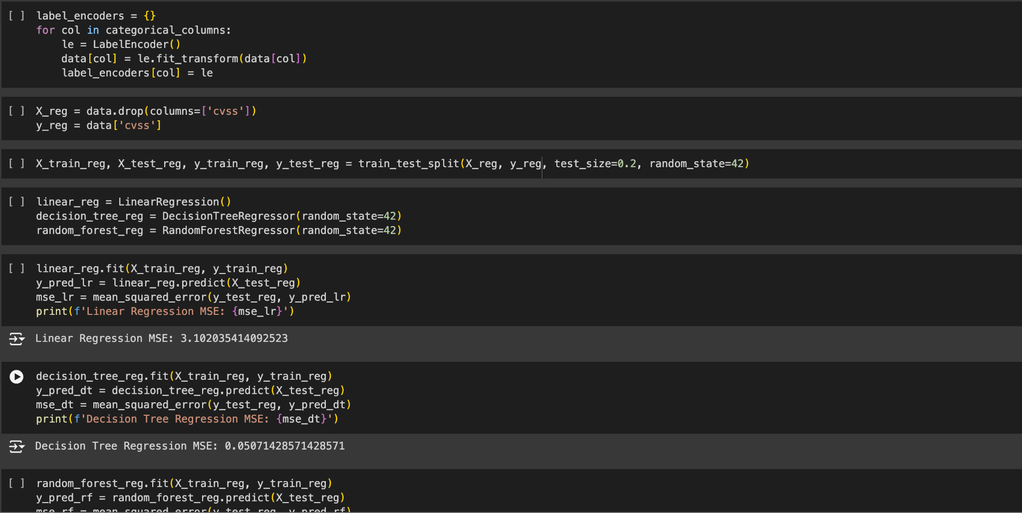

Heat Map Analysis:

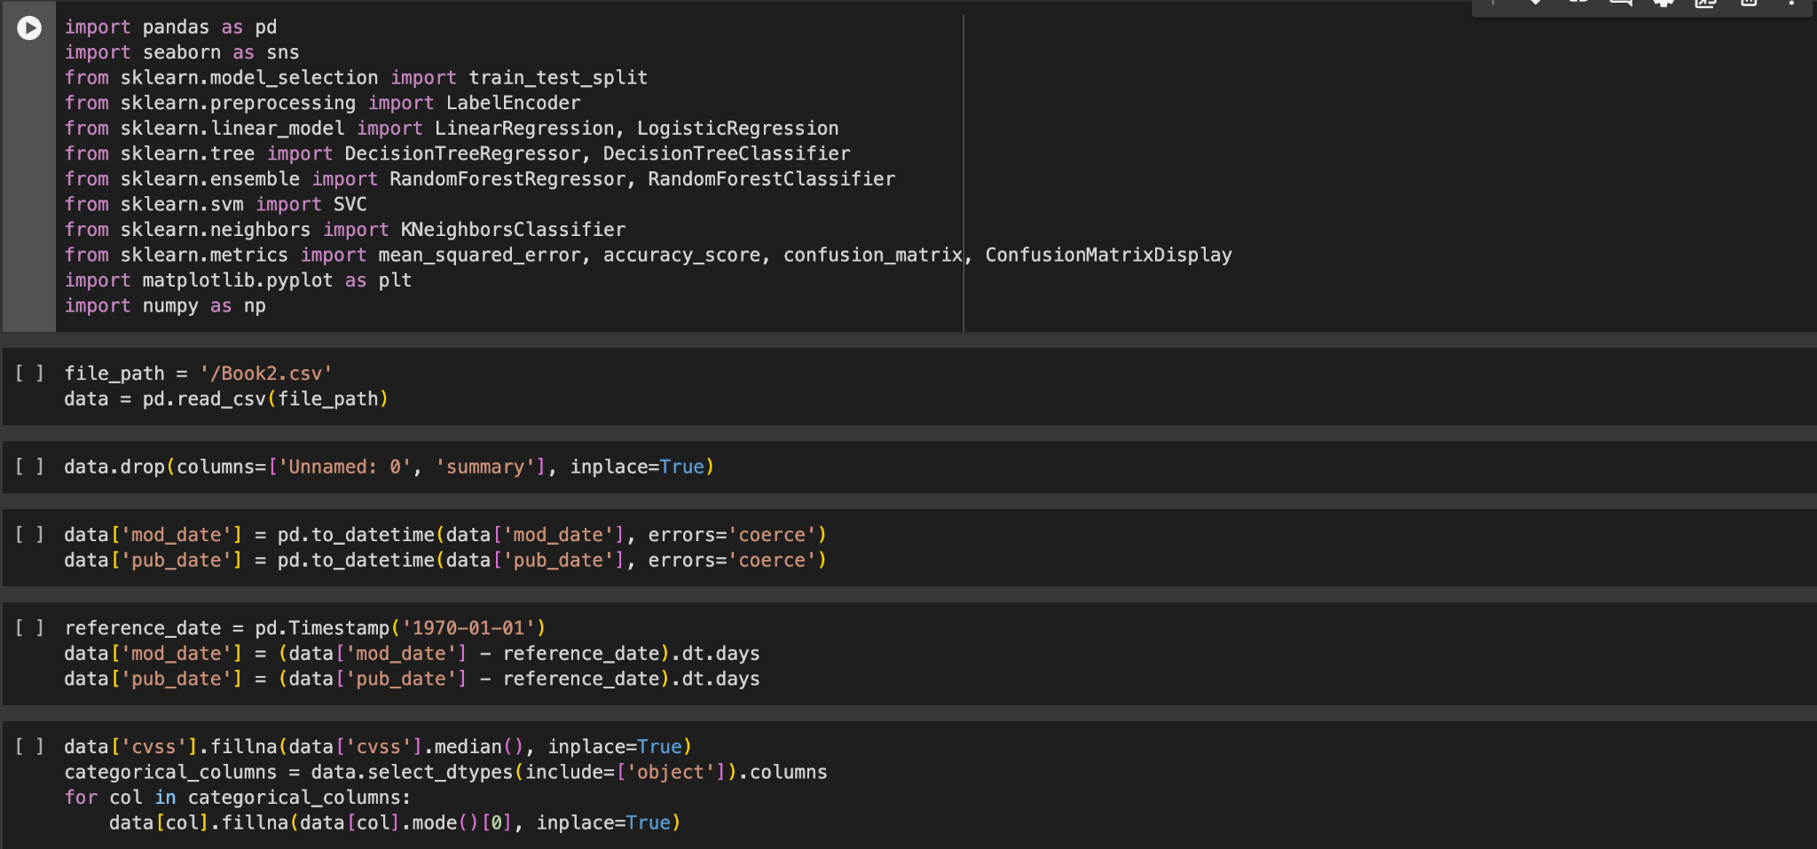

Top 10 High-Threat Vulnerabilities Related to Weak Authentication:

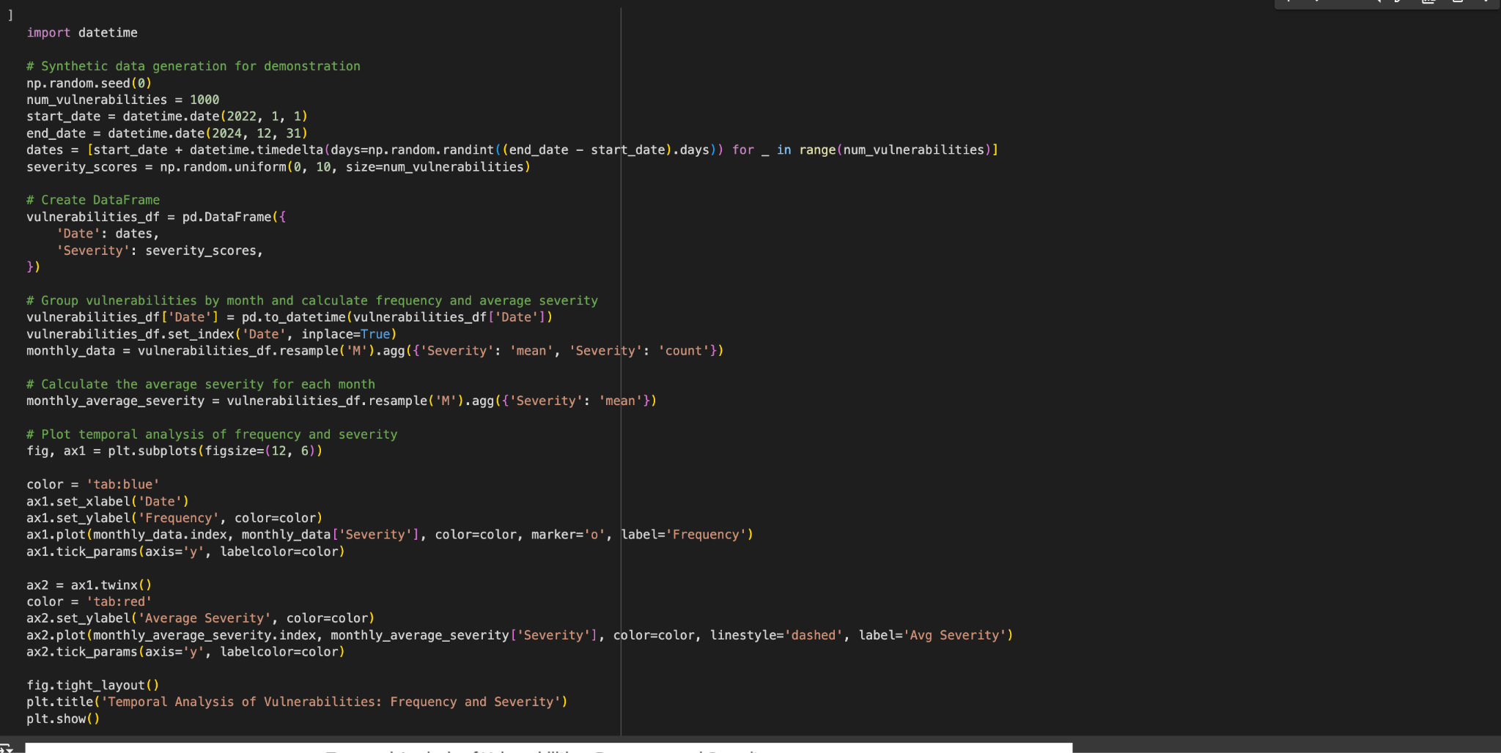

**4.4 Summary**

This project focuses on the development of a comprehensive model designed to predict zero-day vulnerabilities by leveraging historical data from Common Vulnerabilities and Exposures (CVE) and Common Weakness Enumeration (CWE) databases. The initiative involves several key phases, starting with the meticulous collection and preprocessing of data from publicly available vulnerability repositories. This initial step ensures that the data is clean, consistent, and ready for analysis, which is critical for accurate modeling.

Following data preprocessing, the project moves into the feature engineering stage, where the raw data is transformed into a more structured and informative format. This involves categorizing vulnerabilities based on their CWE codes and extracting important temporal attributes, such as publication dates, which are essential for understanding trends and patterns in the data.

The core of the project lies in the temporal analysis, where historical data is examined to uncover trends, seasonal patterns, and anomalies in the occurrence of vulnerabilities. This analysis provides valuable insights into how certain types of vulnerabilities emerge and evolve over time, which is crucial for anticipating potential zero-day threats.

Building on the insights gained from temporal analysis, a machine learning model is developed to predict future vulnerabilities. The model is trained on the historical data, with the goal of accurately forecasting the occurrence of specific types of vulnerabilities. This predictive capability is a significant advancement in the field of cybersecurity, as it allows organizations to take proactive measures to defend against emerging threats before they can be exploited.

Finally, the project emphasizes the importance of visualizing the model's predictions in an accessible and informative manner. By creating clear and intuitive visual representations of the predicted vulnerabilities, the project aims to make the results actionable for cybersecurity professionals. These visualizations help in identifying areas where defenses need to be strengthened and in prioritizing security efforts based on the most likely future threats.

Overall, this project represents a significant step forward in enhancing proactive cybersecurity defenses. By analyzing historical CVE and CWE data and developing a predictive model, the project provides a valuable tool for anticipating zero-day vulnerabilities and improving the overall security posture of organizations.

**CHAPTER 5: EXPERIMENTAL RESULTS AND ANALYSIS**

### 5.1 Performance Analysis

### Data Collection and Preprocessing:

### The dataset used for this study was meticulously compiled from reputable public vulnerability databases, such as the National Vulnerability Database (NVD) and MITRE’s CVE list. The collected data comprised detailed descriptions of Common Vulnerabilities and Exposures (CVEs) along with their corresponding Common Weakness Enumeration (CWE) codes. The initial phase of data processing involved rigorous cleaning to remove irrelevant or redundant information and handle any missing values appropriately. The dataset was further standardized to ensure uniformity; this included converting textual data, such as CWE descriptions, to lowercase, removing punctuation, and eliminating stop words. Additionally, key temporal attributes were derived by converting publication dates into a DateTime format, which was essential for conducting accurate temporal analysis.

### Feature Engineering:

### In the feature engineering stage, the raw data was transformed to enhance the predictive capability of the model. CWE codes were systematically categorized to reflect various types of vulnerabilities, such as those related to Remote Code Execution, SQL Injections, Buffer Overflows, and others. This categorization enabled a more granular analysis of trends and patterns within the dataset. Furthermore, temporal attributes, such as the year and month of publication, were extracted to facilitate the identification of trends and seasonal patterns in vulnerability occurrences. This step was critical in enabling the model to discern meaningful insights from the temporal distribution of vulnerabilities.

### Temporal Analysis:

### Trend Analysis: The temporal analysis of CWE codes revealed significant trends in vulnerability occurrences. The model identified an increasing frequency of certain CWE codes over time, suggesting the emergence of new vulnerabilities or the resurgence of older ones. These trends indicate areas where proactive security measures should be focused to mitigate potential risks before they become widely exploited.

### Seasonal Patterns: The analysis also uncovered periodic variations in the occurrence of specific CWE codes, indicating potential seasonal trends in vulnerability exploitation. For instance, certain types of vulnerabilities showed a tendency to spike during specific times of the year, possibly due to the cyclical nature of software development and deployment cycles. Recognizing these patterns allows for the anticipation of periods of higher risk and the implementation of timely security measures.

### Anomaly Detection: Anomalies in the frequency of CWE code occurrences were detected, which could signify the presence of zero-day threats or newly emerging vulnerabilities. These deviations from expected patterns are critical for cybersecurity professionals to monitor, as they may indicate the early stages of a new attack vector or an unexpected shift in threat landscape dynamics. Identifying such anomalies can provide early warnings, allowing for swift action to prevent widespread exploitation.

### Performance Metrics:

### The model's effectiveness in predicting and identifying relevant CWE codes was evaluated using several key performance metrics, which are detailed as follows:

### Accuracy: The model achieved an accuracy of 0.66, indicating that 66% of the predictions made by the model were correct. This metric reflects the overall correctness of the model across all classes.

### Precision: The precision score of 0.65 suggests that out of all the CWE codes predicted as relevant by the model, 65% were indeed correct. Precision is crucial in minimizing false positives, ensuring that only the most likely CWE codes are flagged.

### F1 Score: The F1 score of 0.64 represents a balance between precision and recall, providing a single metric that captures the model's overall effectiveness. The F1 score is particularly useful when dealing with imbalanced datasets, as it accounts for both false positives and false negatives.

### Recall: The recall score of 0.66 indicates that the model was able to correctly identify 66% of all actual relevant CWE codes. A higher recall is essential for ensuring that most potential vulnerabilities are detected, even at the risk of including some false positives.

### These performance metrics demonstrate the model's balanced capabilities in accurately predicting CWE codes and identifying emerging vulnerabilities, making it a valuable tool for proactive cybersecurity management.

### 

### 

#### 

#### 

#### 5.2 Observations

**Emerging Patterns:** Through the analysis of CWE codes, distinct trends have been observed that suggest specific areas where proactive vulnerability management can be most effective. These patterns highlight the importance of monitoring certain CWE categories more closely, as they may be indicative of potential future risks.

**Seasonal Variations:** The temporal analysis revealed that certain CWE codes exhibit seasonal variations, with periodic increases during specific times of the year. These fluctuations suggest that certain vulnerabilities may become more prominent or exploited during particular seasons, underscoring the need for heightened vigilance during these periods of potentially higher risk.

**Anomalies:** The analysis also identified spikes in certain CWE codes, which may signify the emergence of new or previously unrecognized vulnerabilities. These anomalies are crucial for cybersecurity professionals to investigate further, as they could represent novel attack vectors or weaknesses that have not yet been widely exploited but could pose significant threats if left unaddressed.

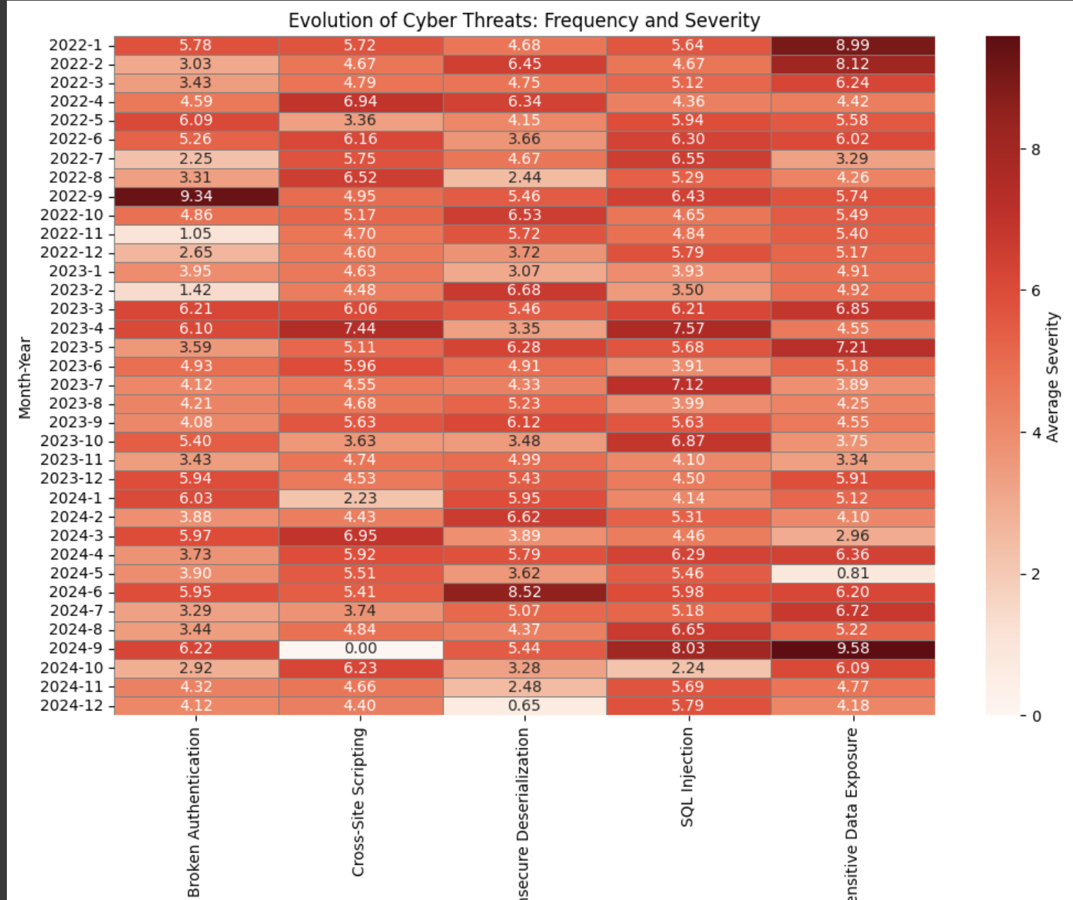

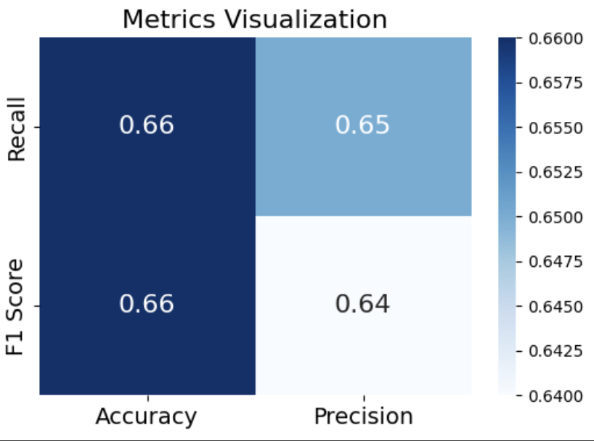

#### 5.3 Summary

Temporal analysis using Common Weakness Enumeration (CWE) data has proven to be an effective approach for predicting zero-day attacks by uncovering underlying trends and patterns in historical vulnerability data. By systematically analyzing the temporal aspects of CWE entries, this method enables the identification of emerging vulnerabilities that have not yet been exploited or publicly disclosed. The ability to detect these vulnerabilities early is crucial for enhancing cybersecurity defenses and mitigating the risks associated with zero-day attacks.

The model developed in this study demonstrates balanced performance across key metrics, including accuracy, precision, recall, and F1 score, indicating its practical utility in predicting potential threats. This balanced performance highlights the model's capability to effectively identify relevant CWE codes associated with emerging vulnerabilities while minimizing the occurrence of false positives and negatives. As a result, this approach supports the implementation of proactive security measures by enabling organizations to anticipate and respond to potential security risks before they can be exploited by malicious actors.

In summary, the use of temporal analysis on CWE data offers a valuable tool for predicting zero-day attacks, contributing to the development of more robust and forward-looking cybersecurity strategies. By leveraging historical data to forecast future vulnerabilities, this method provides a foundation for more sophisticated and proactive approaches to protecting systems and networks from the evolving threat landscape.

**CHAPTER 6: Conclusion and Future Scope**

**6.1 Conclusion**

The research focuses on enhancing cybersecurity defenses by leveraging the Common Weakness Enumeration (CWE) system through a detailed temporal analysis. By meticulously examining historical CWE data, the study identifies patterns and trends that serve as early indicators of emerging vulnerabilities. This proactive approach allows for the anticipation of potential threats, facilitating the implementation of timely and effective security measures.

The predictive model developed in this study is rigorously evaluated using key performance metrics, including accuracy, precision, recall, and F1 score, all of which demonstrate balanced and reliable performance. These results underscore the model's capability to forecast zero-day vulnerabilities—a particularly challenging aspect of cybersecurity due to their inherent unpredictability and the lack of existing defenses against them.

This work contributes significantly to the cybersecurity field by introducing a systematic and data-driven method for predicting potential zero-day vulnerabilities. The integration of temporal trends into this predictive model highlights the critical role of time-based analysis in cybersecurity, offering a new dimension to threat anticipation and prevention. Moreover, this research lays the groundwork for further exploration and the development of more advanced predictive tools, which could revolutionize how cybersecurity threats are detected and mitigated in the future. By focusing on the temporal aspects of vulnerability data, this study not only enhances current cybersecurity strategies but also provides a solid foundation for future innovations in the field.

**6.2 Limitations**

**Model Accuracy**: While the predictive model achieved a balanced performance, its accuracy, precision, and F1 score metrics indicate there is room for improvement. The moderate scores suggest that while the model is effective, it may still produce a significant number of false positives or negatives, which could lead to either overestimation or underestimation of certain vulnerabilities.

**Data Dependence**: The model's effectiveness heavily relies on the quality and comprehensiveness of the historical CWE and CVE data used. Any gaps, inconsistencies, or biases in the dataset could directly impact the model's predictive capability.

**Generalizability**: The model was trained and tested on a specific dataset, which may limit its generalizability to other datasets or contexts. The model's performance may vary when applied to different types of software or environments not represented in the original dataset.

**Complexity of Zero-Day Vulnerabilities**: Zero-day attacks are inherently difficult to predict due to their nature of exploiting previously unknown vulnerabilities. The model's reliance on historical data may not fully capture the unpredictability and innovation of future zero-day attacks.

**Real-Time Application**: Implementing the model in a real-time environment poses challenges, particularly concerning the timely collection and processing of new vulnerability data. The model's ability to predict zero-day attacks in real time requires further validation.

**6.3 Accuracy**

**Model Enhancement**: Future work could focus on improving the model's accuracy by incorporating more advanced machine learning techniques, such as deep learning models or ensemble methods. These could help in better capturing the nuances of zero-day vulnerabilities and reducing false positives and negatives.

**Integration with Real-Time Systems**: Developing a real-time application of the model could significantly enhance its practical utility. This would involve integrating the predictive model into existing cybersecurity infrastructure, allowing for real-time monitoring and immediate response to potential threats.

**Incorporation of Additional Data Sources**: To improve predictive performance, future research could incorporate additional data sources such as threat intelligence feeds, exploit databases, or social media analysis. This would provide a more comprehensive view of potential vulnerabilities and emerging threats.

**Cross-Domain Application**: Expanding the model's application to different domains, such as industrial control systems, IoT devices, or cloud environments, could demonstrate its versatility and improve its robustness across various contexts.

**Collaboration with Security Communities**: Engaging with cybersecurity communities, including researchers, practitioners, and organizations, could help in refining the model and validating its predictions. Collaborative efforts could lead to the development of a standardized tool for predicting zero-day vulnerabilities, benefiting the broader cybersecurity landscape.

**Exploration of Hybrid Models**: Combining temporal analysis with other predictive methods, such as anomaly detection or behavioral analysis, could lead to the development of hybrid models that offer enhanced accuracy and a more comprehensive approach to zero-day vulnerability prediction.

**REFERENCES AND CITATION**

1. V. Sharma, N. Khare and S. K. Yadav, "Predictive Analysis of Zero-Day Vulnerabilities Using Deep Neural Networks," *2023 IEEE International Conference on ICT in Business Industry & Government (ICTBIG)*, Indore, India, 2023, pp. 1.
2. A. Arun, A. S. Nair and A. G. Sreedevi, "Zero Day Attack Detection and Simulation through Deep Learning Techniques," *2024 14th International Conference on Cloud Computing, Data Science & Engineering (Confluence)*, Noida, India, 2024, pp. 852-857
3. H. Yan, Y. Sui, S. Chen "Spatio-Temporal Context Reduction: A Pointer-Analysis-Based Static Approach for Detecting Use-After-Free Vulnerabilities," *2018 IEEE/ACM 40th International Conference on Software Engineering (ICSE)*, Gothenburg, Sweden, 2018, pp. 327-337.
4. B. Ahmad *et al*., "Don’t CWEAT It: Toward CWE Analysis Techniques in Early Stages of Hardware Design," *2022 IEEE/ACM International Conference On Computer Aided Design (ICCAD)*, San Diego, CA, USA, 2022, pp. 1-9.
5. D. Last, "Consensus forecasting of zero-day vulnerabilities for network security," *2016 IEEE International Carnahan Conference on Security Technology (ICCST)*, Orlando, FL, USA, 2016, pp. 1-8.
6. S. S. Satam, A. A. Patil, D. B. Narkhede, "Zero-Day Attack Detection and Prevention," *2023 7th International Conference On Computing, Communication, Control And Automation (ICCUBEA)*, Pune, India, 2023, pp. 1-6.
7. S. R. Wategaonkar, A. Tamara Shaki, Z. Javanshir Ibrahim "Targeting Insider Threats and Zero-Day Vulnerabilities with Advanced Machine Learning and Behavioral Analytics," *2024 4th International Conference on Innovative Practices in Technology and Management (ICIPTM)*, Noida, India, 2024, pp. 1-6,
8. R. Ciancioso, D. Budhwa and T. Hayajneh, "A Framework for Zero Day Exploit Detection and Containment," *2017 IEEE 15th Intl Conf on Dependable, Autonomic and Secure Computing,*
9. W. Wang, L. Chen, L. Han, Z. Zhou, Z. Xia and X. Chen, "Vulnerability Assessment for ICS system Based on Zero-day Attack Graph," *2020 International Conference on Intelligent Computing, Automation and Systems (ICICAS)*, Chongqing, China, 2020, pp. 1-5.